**Developed Market Research**

Planet Game

* Casual gamers
  + Game focuses on ‘casual mechanics’ such as sorting and managing.
  + Players have a natural liking for sorting, particularly when the characteristics being sorted are obvious **(Trefry, p.127)**
* Mobile
  + In 2017, 79% of sales were in the digital format. This includes subscriptions, digital copies of full games, digital add-on content, mobile apps and social network games **(ESA Annual Survey 2018)**
  + 57% of mobile gamers play daily **(Strategyr)**
  + Makes it easy to play on the go and in small sessions
    - 31% of mobile gamers play in bed, while 16% of them play on the bus or train **(Strategyr)**
    - Casual players enjoy shorter session times **(Mobile Games Blog)**
* Females, between the ages 25-50
  + Looking at a study conducted by the Mobile Games Blog for Bejewelled Blitz, 78.2% of players were female, of which the majority were between the ages of 25-44 **(Mobile Games Blog)**
  + The average age of a female video game player is 36 **(ESA Annual Survey 2018)**
  + 45% of US gamers are women **(ESA Annual Survey 2018)**
  + 69% of respondents who enjoyed match 3 and family/farming sim games are women **(Mobile Games Blog)**
  + 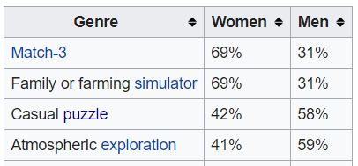

Figure 1: Chart showing % of gamers in each genre that are female. This shows that match 3 and family/farm sim gamers are most likely to be female. Statistics pulled from Quantic Foundry (2)

* + 53% of mobile gamers are female **(Strategyr)**
  + Women have a natural desire to nurture (**Psychology Today)**
  + “Women consistently rank values strongly linked to environmental concern… as more important than men do.” **(LA Times)**
  + For women, completion and design are among the most common primary motivations for playing games **(Quantic Foundry (1))**
* 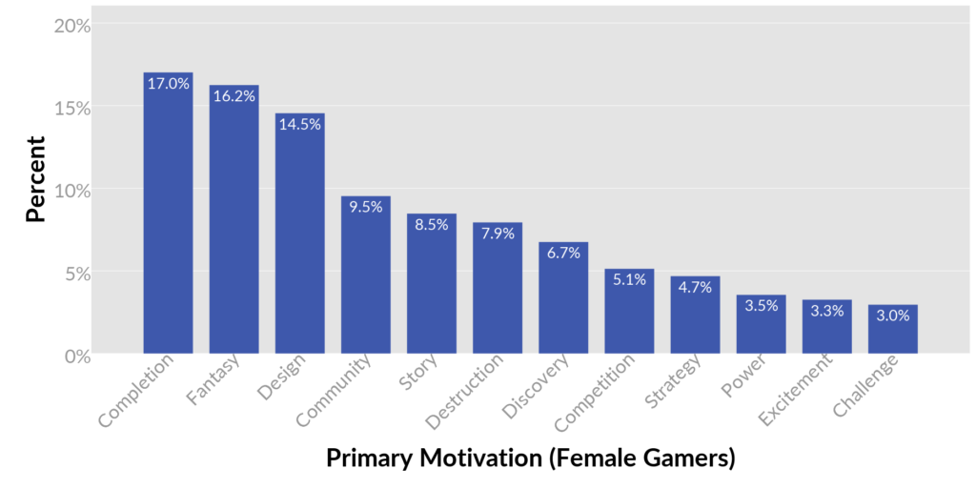Five things females like to see in games **(Jesse Schell)**
  + Real world; when things are connected to the real world in a meaningful way, women become more interested. This may be through the content (simulating life of ordinary people), or through the social aspects of the games
  + Nurturing; females enjoy nurturing, the success of farming games and pet games with girls and women is largely due to the nurturing mechanics
  + Learning by example; women have a strong appreciation for clear tutorials that lead you carefully, step by step so that they know what to do when they need to complete a task
  + Emotion
  + Dialog and verbal puzzles
* Competitors; what are some similar games on the market
  + Incremental
    - Plantera; player can plant different types of seeds and earn coins upon harvesting, as the player progresses they unlock the ability to purchase new seeds, as well as animals
    - My Oasis; player has the ability to click and gain hearts to spend on upgrades and new animals for their island
    - Terrarium (incremental idle game); player has the ability to add new pot plants to their terrarium and collect oxygen from them to upgrade, when the player levels up they have the ability to unlock new plants
    - Abyssrium; players click to collect vitality which can be used to grow corals and unlock fish
    - Neko Atsume (incremental idle game); player decorates their yard with “goodies” in order to attract different cats - player can then photograph these cats to fill out their photo album
  + Majority of these games tend to be clickers, therefore ours is different as we intend to use a sorting mechanic for the purpose of progression/unlocking new objects

Sources

* <http://www.theesa.com/wp-content/uploads/2018/05/EF2018_FINAL.pdf>
* <http://developers.magmic.com/demographic-breakdown-casual-mid-core-hard-core-mobile-gamers/>
* <https://www.strategyr.com/MarketResearch/Wireless_Gaming_Market_Trends.asp>
* <https://www.psychologytoday.com/us/blog/complete-without-kids/201103/woman-s-biological-need-nurture-and-how-satisfy-it-when-you-re-not>
* <http://articles.latimes.com/2012/jun/13/opinion/la-oe-polakovic-gender-and-the-environment-20120613>
* (1) <https://quanticfoundry.com/2016/12/15/primary-motivations/>
* (2) <https://quanticfoundry.com/2017/01/19/female-gamers-by-genre/>
* Casual Game Design, Designing Play for the Gamer In All of Us - Gregory Trefry
* The Art of Game Design, A Book of Lenses – Jesse Schell

Consumer Profile

* Patricia, 37 years old
* Lives in Peterborough and commutes by train to get to work
* Has a family; may be able to play the game with her children or use it to unwind once they have been put to bed
  + Married with 2 young children
* Uses Facebook
  + Can use targeted marketing/ads
* Owns an Android device
* Financially independent; may be able play the game on her commute to work or during work breaks
  + Office/sales administrator in London
* Enjoys gardening, cake decorating and bird watching
  + Uses Pinterest to find interesting recipes that she can experiment with
* Enjoys colouring pages/paint by numbers to relax during spare time
* Also plays match 3 and casual puzzle games
* Favourite colours are blue and purple
* Tidy person
  + Likes bringing order to chaos ∴ will enjoy matching/sorting mechanics
* Is an animal lover
  + A pet cat called Tigger
* Eco-concious; recycling is important to her
* What food does she eat?
  + Favourite food; Italian cuisine, particularly enjoys pasta dishes such as Carbonara and Fettuccine Alfredo
  + Often makes kid-friendly but balanced meals throughout the work week
* TV and Film preferences
  + Spring watch, Doctor Who, Parks and Recreation
  + Food network channel
  + Studio Ghibli films; Princess Mononoke and Spirited Away
  + Tim Burton films
* Music and Books
  + 80s and modern pop; favourite band is Take That
  + Romance novels; Danielle Steele is her favourite author
* Clothes she likes
  + Zara and Mango; work wear
  + Dorothy Perkins, Fat Face, M&S and Next.
  + ASOS
* Doesn’t have a dedicated exercise regime but tries to reach her daily step goal
  + Would like to go to the gym but struggles to find time
* What is in her bedroom
  + Vanity table
  + Canvas prints and family photos
  + Bedside table; stack of books
  + Lots of cushions on the bed
  + Modern greys with hints of plum purple



* Does she like to share or is she a private person (this will guide whether we include features such as leaderboards etc.)
  + Values her time with a small group of friends, isn’t overly competitive but enjoys sharing her achievements with them

Daily Routine

* 6:00; wakes up and goes for a shower
* 6:10; get dressed and ready
* 6:35; have breakfast
* 6:45; get kids ready
* 7:05; leave for train station, husband finishes getting kids ready and drops them off at school
* Take 7:19 train from Peterborough for London Liverpool street, arriving at 8:36
  + Train journey – approx. 1h 15m
* 9:00; work starts
* 10:30; 5 minute morning break before going back to desk
* 13:00; lunchtime for one hour
* 14:00; carry on working until 17:00
* Take 17:22 train from London Liverpool Street, arrives in Peterborough 18:36
* 18:50; gets home and begins cooking dinner
  + Husband has already picked kids up from school
* 19:40; dinner ready to eat with family
* 20:00; get kids ready for bed
* 20:30; kids in bed and time to relax
* 23:00; bed time